**Global Distribution & Data Center Outage in Cosmos DB**

1. **What?**

Azure Cosmos DB simplifies the global distribution of data by offering fully managed, multi-region database accounts that provide clear trade-offs between consistency, availability, and performance, all with corresponding guarantees. Cosmos DB is available in all new regions by default as it is classified as a foundational service in Azure. This feature helps in distributing Cosmos database in the upcoming new regions easily.

Cosmos DB has following types of databases:

* Primary Database

It’s also called as “Write” database and is a main database. All the core database operations like insert, update and delete operations are done in this database

* Secondary Databases

These are replica of the primary database which is used to speed up the data accessing in retrieval. Azure allows to select any number of read data regions, but every single selection is cost oriented. Data replication in various regions across the globe is very fast and durable with a Secondary Database.

1. **How it Works?**

Azure Cosmos DB allows to associate any number of Azure regions with Cosmos DB database account at any point in time. Azure Cosmos DB ensures that the automatic failover sequence occurs in the priority order specified while creating secondary databases. Cosmos DB supports controlling of the end-to-end system behaviour in the event of failures. If the affected region is the current write region and automatic failover is enabled for the Azure Cosmos DB account, then the region is automatically marked as offline. Then, an alternative region is promoted as the write region for the affected Azure Cosmos DB account.

1. **How to run the sample?**

To sample contains two parts.

* 1. **01CosmosDBCreationPoC.ps1** - PowerShell Scripts to work with Cosmos DB infrastructure (creating database, attaching regions, failover operation)
  2. **02CosmosDBCreationPoC** - .NET C# sample, which will work as client for Cosmos DB (for insert, delete and retrieval of data). Following updates need to be done in App.config file of DocumentManagement project before running the application.

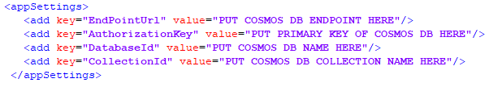

* 1. **03CosmosDBCreationPoC.ps1** – This script will do a failover operation to West US region and make it Write database.